Give your Appaloosa a spot in history…
…And help to build a colorful heritage
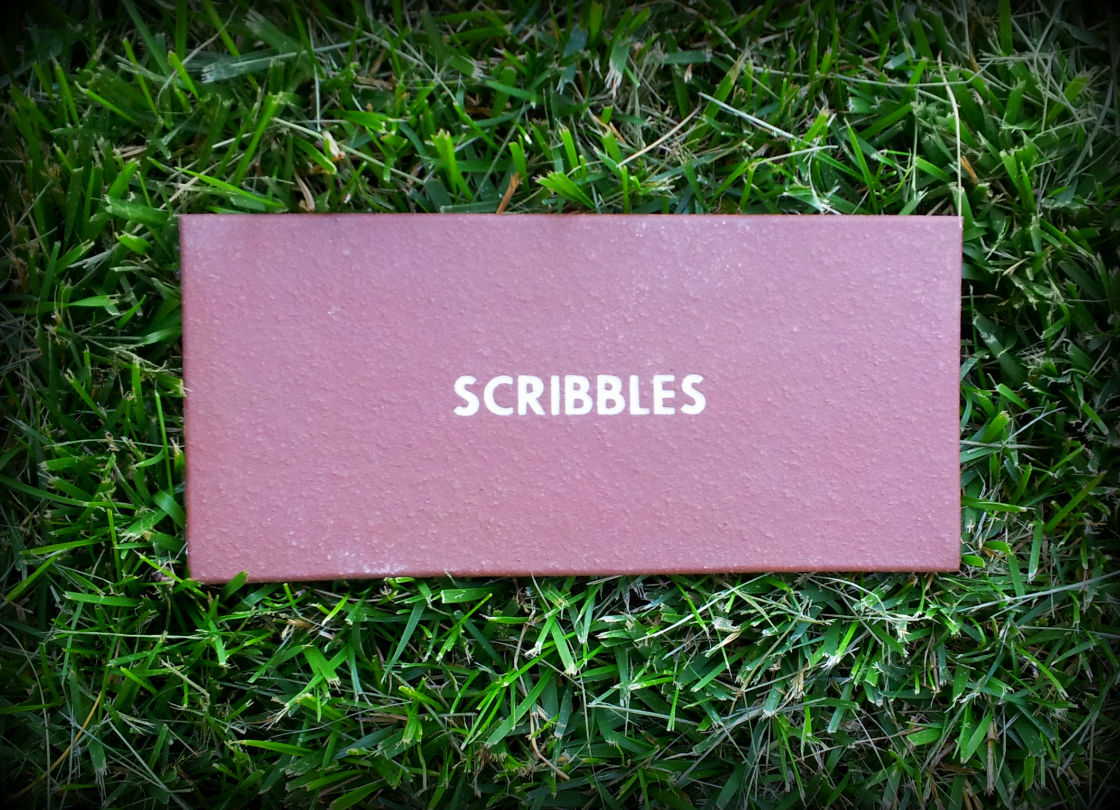
To honor and celebrate the individual horses that make up our fine breed, the Appaloosa Museum & Heritage Center offers a Walk of Fame where Appaloosas of today and yesterday are honored with an engraved tile.
For your $125 donation to the Appaloosa Museum & Heritage Center, a tile will be specially engraved with the name of your Appaloosa. It will be placed in the museum as a permanent tribute to the horse who has gained your, and the Appaloosa industry’s, love and respect.
Please fill out the order form using the registered name (preferred) or name under which the horse was shown. If you have any questions, please call (208) 882-5578 ext. 279 (Pacific Standard Time).
Please note: There is maximum of 20 characters per line, with up to three lines total for each tile, this includes spaces and punctuation. Tiles tend to read the clearest with only one line of type. Please do not include names of people.
Please Print in All Upper Case. Thank You!
Tile 1:
Tile 2:
Tile 3:
Please Complete This Order Form:
Name __________________________________________________________
Address _________________________________________________________
City _____________________________________ State _____ Zip _________
Phone ___________________________________
Email ___________________________________
Payment Method:
Check Credit Card
Card Number ____________________________________
Exp Date _____________ CVN ________________
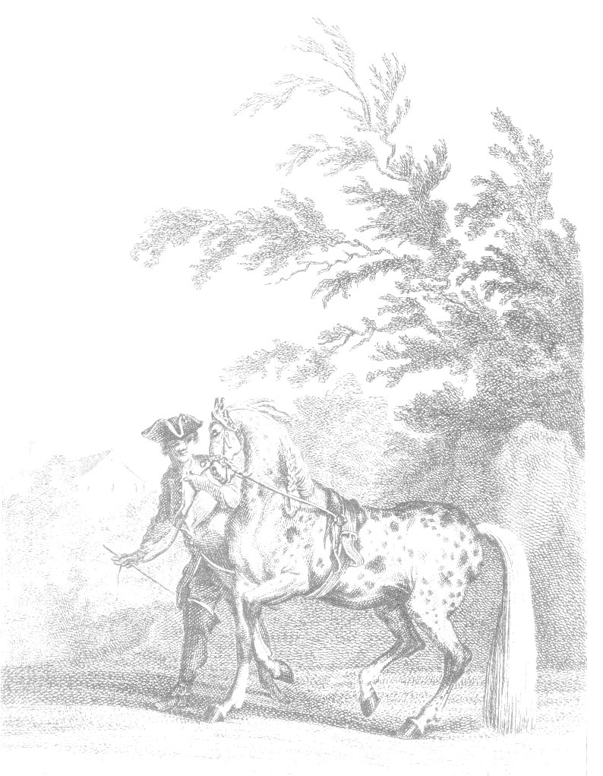
Signature ________________________________________

